Steps to retrieve learner certificate URLs for a course

- Replace <course-name> with the name of the course you are looking (Ensure that single quotes are present) for in the database query given below.
Query

SELECT [CourseID]
,[CourseName]
,[CertificateStatus]
,[ContentLanguage]
,[ParentCourseId]
,[OrgId]
,[IsPublished]
,[FeedbackFormURL]
,[ImportContentType]
,[ImportContentURL]

FROM [MSLCatalog].[Course]
WHERE [CourseName] LIKE '<course-name>';
- Run the above query and save the CourseID for the required course from the results of the query.
- Replace <course-id> in the below query with the CourseID that you got from step 2.
Replace <content-endpoint> in one of the following ways:-
  - If AzureFD is present, then replace <content-endpoint> with AzureFD website URL followed by “/storage/”.
Eg:- For devsangam.azurefd.net, <content-endpoint> will be replaced with https://devsangam.azurefd.net/storage/

  - If websites is an Azurewebsites URL, then replace <content-endpoint> with the Blob service URL, which can be found by accessing the storage account on the Azure portal.
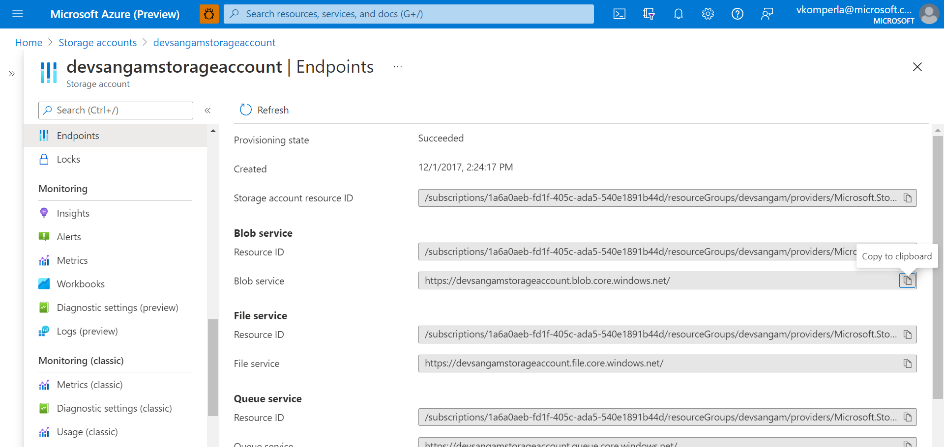
Eg:- For devsangam storage account, the <content-endpoint> will be replaced with https://devsangamstorageaccount.blob.core.windows.net/

Query
SELECT [MSLCatalog].[LearnerCourseActivity].[UserID]
,[MSLCatalog].[LearnerCourseActivity].[CourseID]
,[MSLCatalog].[MLXUser].[FirstName]
,[MSLCatalog].[MLXUser].[LastName]
,[MSLCatalog].[MLXUser].[EmailAddress]
,[MSLCatalog].[LearnerCourseActivity].[CourseEndDatetime]
,REPLACE([MSLCatalog].[LearnerCourseActivity].[CertificateUrl], '{ContentEndpoint}/','<content-endpoint>') AS CertificateUrl
,[MSLCatalog].[LearnerCourseActivity].[Score]
,[MSLCatalog].[LearnerCourseActivity].[CertificateStatus]
,[MSLCatalog].[LearnerCourseActivity].[LearnerCourseActivityID]

FROM [MSLCatalog].[LearnerCourseActivity]
INNER JOIN [MSLCatalog].[MLXUser]
ON [MSLCatalog].[LearnerCourseActivity].[UserID] = [MSLCatalog].[MLXUser].[UserID]
WHERE CourseID = <course-id>;

- Run the above query to get learner certificate URLs for a given course.

